1. **ReentrantLock:**
   1. Same behavior as that of synchronized block.
   2. With additional features.
2. **ReentrantLock**
   1. Class.
   2. Implementation for Lock(I).
   3. 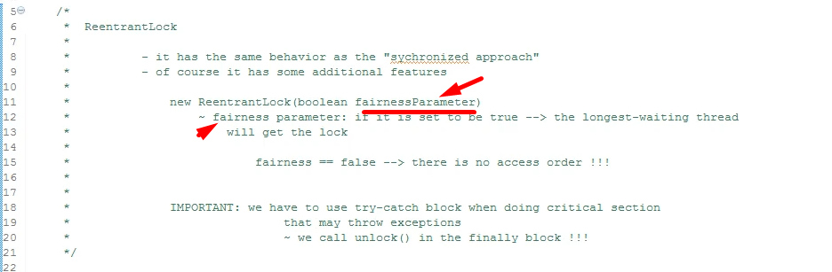
3. **Code**:  
   